Principal Component Analysis(PCA)

PCA (Principal Component Analysis) is a dimensionality reduction technique used in data analysis and machine learning. It helps you to reduce the number of features in a dataset while keeping the most important information. It changes your original features into new features these new features don’t overlap with each other and the first few keep most of the important differences found in the original data.

PCA is commonly used for data preprocessing for use with machine learning algorithms. It helps to remove redundancy, improve computational efficiency and make data easier to visualize and analyze especially when dealing with high-dimensional data.

How Principal Component Analysis Works

PCA uses linear algebra to transform data into new features called principal components. It finds these by calculating eigenvectors (directions) and eigenvalues (importance) from the covariance matrix. PCA selects the top components with the highest eigenvalues and projects the data onto them simplify the dataset.

Step 1: Standardize the Data
Different features may have different units and scales like salary vs. age. To compare them fairly PCA first standardizes the data by making each feature have:
A mean of 0
A standard deviation of 1
Z=X−μ/σ

where:
μμ is the mean of independent features μ={μ1,μ2,⋯,μm}
σ is the standard deviation of independent features σ={σ1,σ2,⋯,σm}

Step 2: Calculate Covariance Matrix
Next PCA calculates the covariance matrix to see how features relate to each other whether they increase or decrease together. The covariance between two features x1x1​ and x2x2​ is:
cov(x1,x2)=∑i=1n(x1i−x1ˉ)(x2i−x2ˉ)n−1cov(x1,x2)=n−1∑i=1n​(x1i​−x1ˉ)(x2i​−x2ˉ)​
Where:
xˉ1andxˉ2xˉ1​andxˉ2​​ are the mean values of features x1andx2x1​andx2​
nn is the number of data points
The value of covariance can be positive, negative or zeros.

Step 3: Find the Principal Components
PCA identifies new axes where the data spreads out the most:
1st Principal Component (PC1): The direction of maximum variance (most spread).
2nd Principal Component (PC2): The next best direction, perpendicular to PC1 and so on.
These directions come from the eigenvectors of the covariance matrix and their importance is measured by eigenvalues. For a square matrix A an eigenvector X (a non-zero vector) and its corresponding eigenvalue λ satisfy:
AX=λX
This means:
When A acts on X it only stretches or shrinks X by the scalar λ.
The directi

on of X remains unchanged hence eigenvectors define "stable directions" of A.
Eigenvalues help rank these directions by importance.

Step 4: Pick the Top Directions & Transform Data
After calculating the eigenvalues and eigenvectors PCA ranks them by the amount of information they capture. We then:
Select the top k components hat capture most of the variance like 95%.
Transform the original dataset by projecting it onto these top components.
This means we reduce the number of features (dimensions) while keeping the important patterns in the data.

In the above image the original dataset has two features "Radius" and "Area" represented by the black axes. PCA identifies two new directions: PC₁ and PC₂ which are the principal components.
These new axes are rotated versions of the original ones. PC₁ captures the maximum variance in the data meaning it holds the most information while PC₂ captures the remaining variance and is perpendicular to PC₁.
The spread of data is much wider along PC₁ than along PC₂. This is why PC₁ is chosen for dimensionality reduction. By projecting the data points (blue crosses) onto PC₁ we effectively transform the 2D data into 1D and retain most of the important structure and patterns

from sklearn.decomposition import PCA

pca = PCA(n_components=2)
X_pca = pca.fit_transform(X_scaled)

Linear Discriminant Analysis in Machine Learning

When working with high-dimensional datasets it is important to apply dimensionality reduction techniques to make data exploration and modeling more efficient. Linear Discriminant Analysis (LDA) also known as Normal Discriminant Analysis is supervised classification problem that helps separate two or more classes by converting higher-dimensional data space into a lower-dimensional space. It is used to identify a linear combination of features that best separates classes within a dataset.

For example we have two classes that need to be separated efficiently. Each class may have multiple features and using a single feature to classify them may result in overlapping. To solve this LDA is used as it uses multiple features to improve classification accuracy. LDA works by some assumptions and we are required to understand them so that we have a better understanding of its working

Key Assumptions of LDA
For LDA to perform effectively, certain assumptions are made:
Gaussian Distribution: The data in each class should follow a normal bell-shaped distribution.
Equal Covariance Matrices: All classes should have the same covariance structure.
Linear Separability: The data should be separable using a straight line or plane.

If these assumptions are met LDA can produce very good results. For example when data points belonging to two classes are plotted if they are not linearly separable LDA will attempt to find a projection that maximizes class separability.

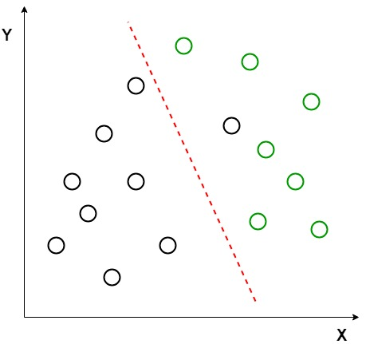
Image shows an example where the classes (black and green circles) are not linearly separable. LDA attempts to separate them using red dashed line. It uses both axes (X and Y) to generate a new axis in such a way that it maximizes the distance between the means of the two classes while minimizing the variation within each class.

This transforms the dataset into a space where the classes are better separated. After transforming the data points along a new axis LDA maximizes the class separation. This new axis allows for clearer classification by projecting the data along a line that enhance the distance between the means of the two classes.

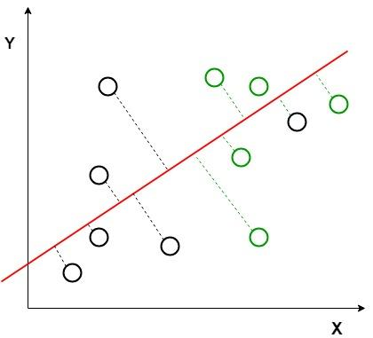
Perpendicular distance between the decision boundary and the data points helps us to visualize how LDA works by reducing class variation and increasing separability. After generating this new axis using the above-mentioned criteria all the data points of the classes are plotted on this new axis and are shown in the figure given below.

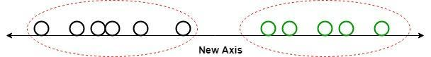
It shows how LDA creates a new axis to project the data and separate the two classes effectively along a linear path. But it fails when the mean of the distributions are shared as it becomes impossible for LDA to find a new axis that makes both classes linearly separable. In such cases we use non-linear discriminant analysis.
How does LDA work
LDA works by finding directions in the feature space that best separate the classes. It does this by maximizing the difference between the class means while minimizing the spread within each class.

Let’s assume we have two classes with d-dimensional samples such as x1,x2,...xn where:
n1​ samples belong to class c1
n2​​ samples belong to class c2​​.
If xi​ represents a data point its projection onto the line represented by the unit vector v is vTxi​​. Let the means of class c1​ and class c2​​ before projection be μ1​ and μ2 respectively. After projection the new means are μ^1=vTμ1μ^​1​=vTμ1​and μ^2=vTμ2μ^​2​=vTμ2​​.
Our aim to normalize the difference ∣μ^1−μ^2∣∣μ^​1​−μ^​2​∣to maximize the class separation. The scatter for samples of class c1c1​​ is calculated as:
s12=∑xi∈c1(xi−μ1)2s12​=∑xi​∈c1​​(xi​−μ1​)2

Extensions to LDA
Quadratic Discriminant Analysis (QDA): Each class uses its own estimate of variance (or covariance) allowing it to handle more complex relationships.
Flexible Discriminant Analysis (FDA): Uses non-linear combinations of inputs such as splines to handle non-linear separability.
Regularized Discriminant Analysis (RDA): Introduces regularization into the covariance estimate to prevent overfitting.

from sklearn.discriminant_analysis import LinearDiscriminantAnalysis

lda = LinearDiscriminantAnalysis(n_components=2)

